BOBBLE TOTE
Materials needed:
Yarn: Super bulky/size 6 yarn (Big Twist Natural Blend in light grey for color A and Lions Brand Wool Ease Thick and Quick in Fig for color B)
Approximately 150 yards of color A and 150 yards of color B
Crochet Hook: M/9mm
Yarn needle
Tape Measure (optional)
Stitch Abbreviations:
Ch – Chain
Sc – Single Crochet
Sc2tog – Single crochet 2 together
PS – Puff Stitch*
*Puff Stitch – (Yarn over and insert your hook into the stitch, yarn over and pull up a loop) 4 times. Yarn over and pull through all loops on hook except the last one. Yarn over and pull through last 2 loops on your hook.
Tote
*There are two sizes in this pattern. The numbers in parenthesis are for the larger size. The small size holds two small skeins and the large holds three or four depending on the yarn. Happy Crocheting!!

Ch 16 (24)
Round 1
Sc in second ch from hook and in next 13(21) [total of 14(22) sc]
5 sc in last stitch
Working along the other side of your starting chain, sc in next 13(21)
5 sc in the last stitch
Slip stitch in first sc to join
Total of 37(53) sc
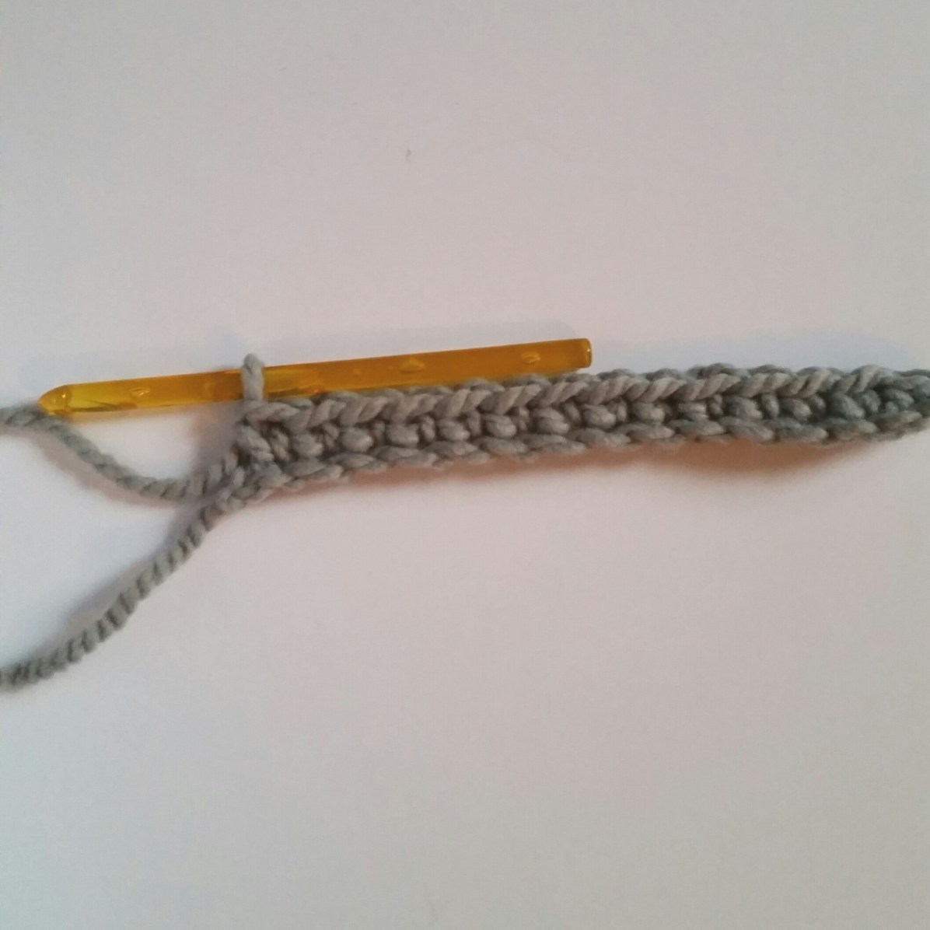
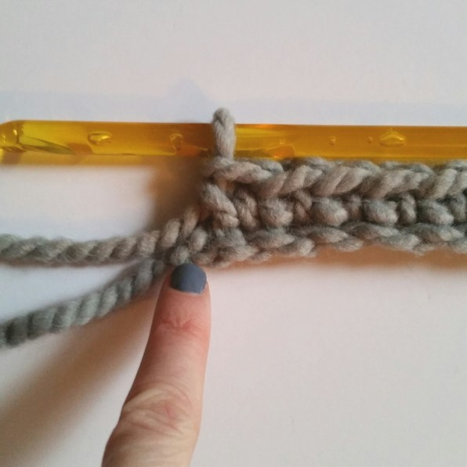
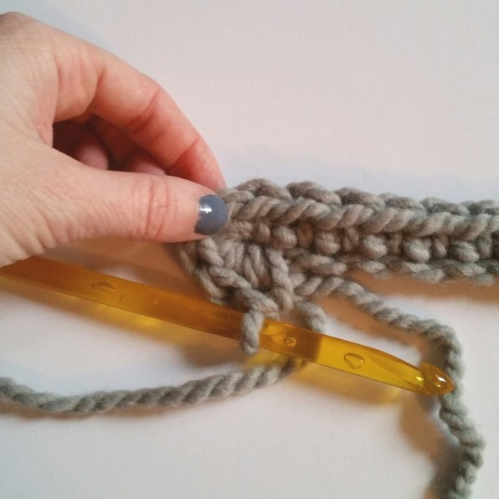
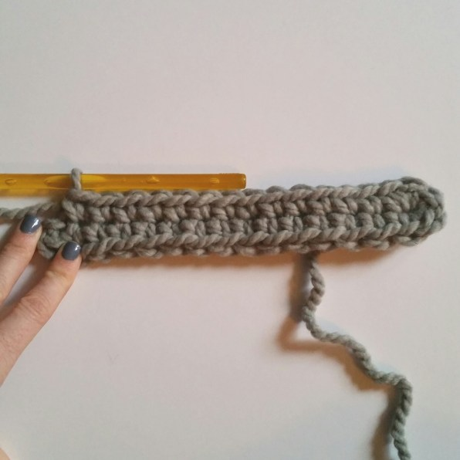
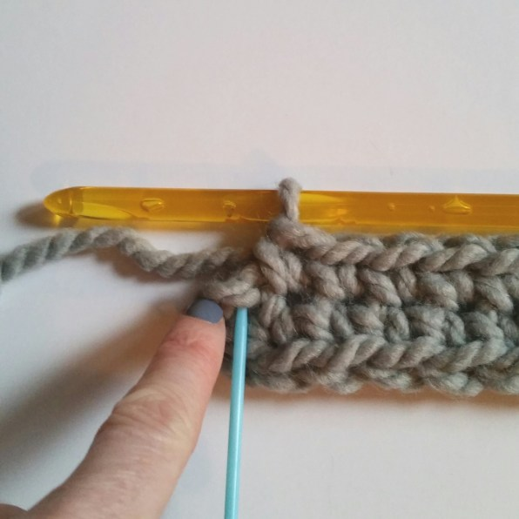
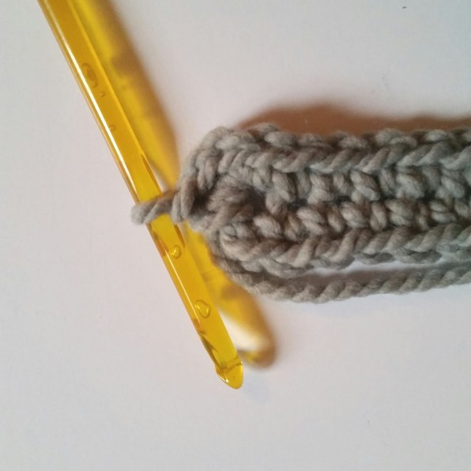
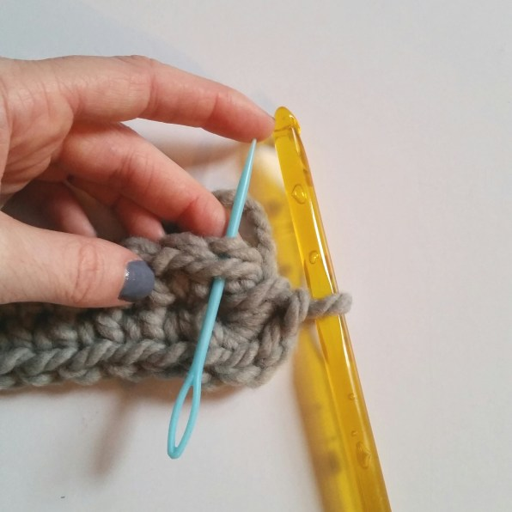
Round 2
Ch 1 and sc in the same stitch as join
Sc in next 14(22) stitches
2 sc in next 3 stitches (around the end)
Sc in next 16(24)
2 sc in next 3 stitches
Join with a sl st to the top of the first sc from round 2
Total of 43(59) sc
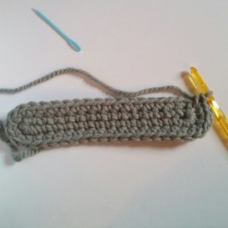
Round 3
Ch 1 and sc in the same stitch as join
Sc in next 15(23) stitches
*2 sc in next, 1 sc* repeat from * to * twice more
Sc in next 16(24)
*2 sc in next, 1 sc in next stitch* repeat from * to * twice
Join with sl st to the top of the ch 1
Total of 50(66)

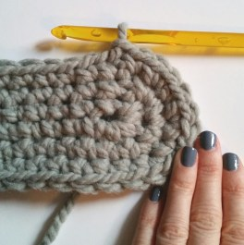
For the remaining rounds, work continuously without joining and chaining
Rounds 4-17 (20)
Sc in each stitch around [Total of 50(66) sc]
Use a stitch marker if you have any trouble seeing where your rows begin. (purple yarn in picture)
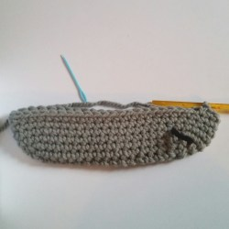
Hole for yarn (optional): Round 6 and 12, sc in each stitch until you’ve gotten to the side of your bag. (Different stitch count depending on the row) Lay your tote flat to be sure you’re working on the crease on the edge. Ch 1 and skip the next stitch to leave a hole for your yarn to work through. Continue sc in all other stitches.
